TECHNICAL DOCUMENTATION – ELECTRICAL APPLIANCES (WASHING MACHINE, VACUUM CLEANERS, GENERATORS ETC.)

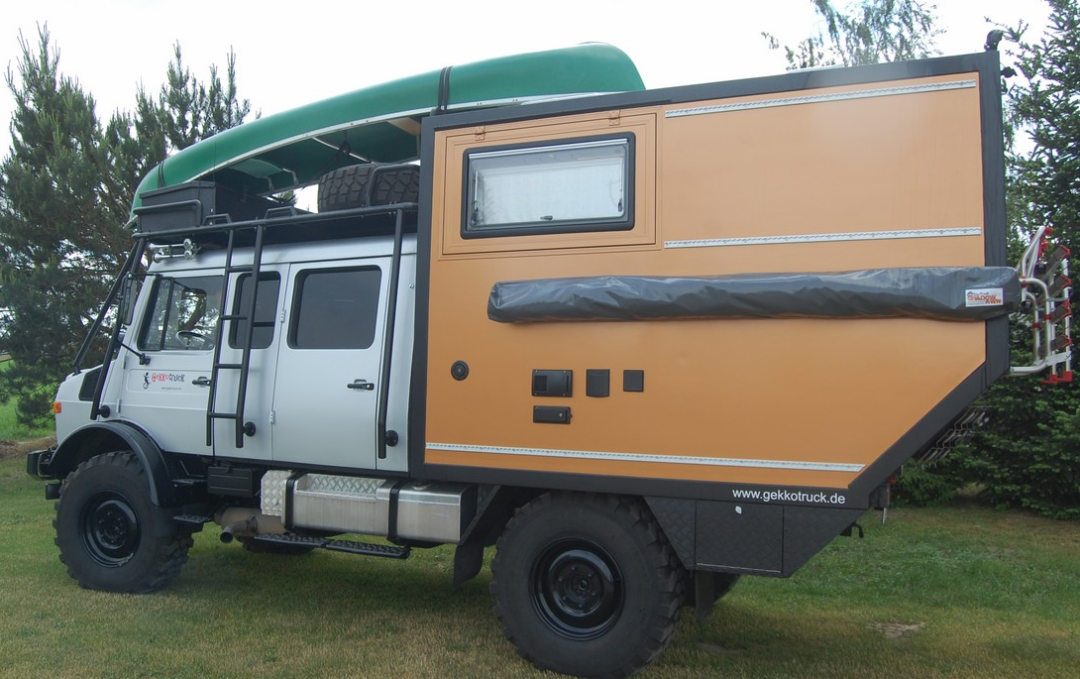

SUMMARY
There are a number of additional electrical ‘household electrical appliances’ which some expedition vehicle owners will feel are almost as important as the ‘basic standard’ and otherwise built-in appliances, and this technical document provides a brief comparison between a number of these.
Underpinning all appliances is the potential requirement for a 230/240v generator, which whilst in general is not required by most vehicle owners, is always a useful back-up, and for travelers either wishing to use air conditioning, and or some ‘heavier’ electrical appliances (such as microwaves, electrical based water heaters or larger washing machines) eases the load on their 12v to 240v inverters, solar panels and batteries.
Despite globalization, household appliances often vary significantly across countries, in terms of their availability (of model types), and pricing (especially if older model types). Gekkotruck usually looks at availability of any type of appliance in Poland, the UK and Germany, as these are very accessible to us, and usually provide a good balance between availability, choice and best price. Whilst the US market also often offers a very competitive pricing, many manufacturers/suppliers limit their range to only 110v models.
Polish prices are often the most competitive, although some European models and manufacturers are less active there, whereas volume of supply means a more competitive pricing on certain appliances from the UK id possible. In general, Germany offers good pricing on most items, particularly if one searches across different supply chains, although there are notable exceptions (for example, Dyson vacuum cleaners continue to represent the peak/premium brand in Germany, whereas are ‘middle priced’ in the UK – similarly Bosch/Siemens appliances are ‘middle priced’ in Germany and premium in the UK).
Relatively very few appliances include 12v model versions, given that it is harder to achieve a good performance whilst keeping electrical currents and cable thicknesses reasonably small – also volume of supply is clearly much lower than mains voltage devices (hence few are produced) – therefore, the use of a 230/240v appliance, together with a generator or the 12v/240v inverter is often the only option, meaning that care should be taken when selecting a 240v based appliance.
In addition to the overall power requirements of the item, one should be aware of any ‘starting or peak power’ demands (i.e. some appliances such as microwaves will have a varying and/or peak power usage above the stated ‘average’ power consumption), which unfortunately are not generally stated clearly on many appliances (please refer to table below as a guide) – it is noted that the ability for inverters and generators to operate briefly above their stated power outputs may be enough to cover any ‘start up’ electrical demand peaks, but the safest rule is to ‘over specify’ the generator or inverter wherever possible.
Similarly, whether taking electricity from an inverter or a generator, the given appliances ability to handle ‘simple or pure form’ of electrical AC supply will also vary, and at Gekkkotruck we always fit ‘pure sine wave’ inverters of ‘good quality/performance’, and similarly strongly advise our customers to choose ‘inverter based generators’, should they wish to use 240v generators.
The following tables provides an overview as to typical electrical requirements of some on-board appliances, together with an indication of those requiring over-specified inverters/generators:
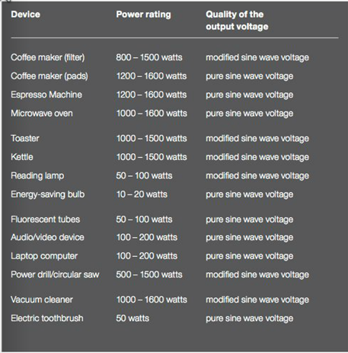
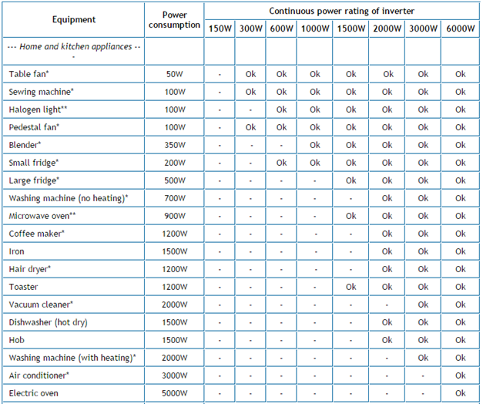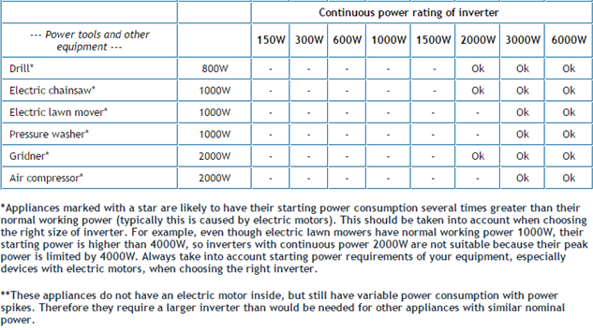
The standard inverter that we fit provides a 900W, 240v pure sine wave supply, with a 2 second peak power to 1600W - we offer upgrades to 2, 3 and even 5kw, although additional batteries/solar panels would usually be advised to be fitted to provide the necessary underlying sustainable power. The Waeco 1800W pure sine inverter provides sustained power at 1800W and a brief (2 seconds) peak of 3200W. We also use Mastervolt or Kontron inverters where customers specifically request, and/or where their energy needs are more demanding.
Batteries that we fit are 200 Amp-hour gel based batteries, although if customers have a preference, we will also fit other battery types (such as Lithium-ion or Optima spiral cell technologies [using the Optima marine models best suited to the life of an expedition vehicle]), although these batteries are considerably more expensive than standard AGM or gel batteries, which are adequate for ‘standard’ users.
Whilst power usage is an important consideration for the use of an appliance within an expedition vehicle environment, then other factors should be included also, particularly size/weight, sensitivity to operating environment (humidity, max/min temperatures), ease of repair/maintenance/warranty, and robustness in design from movement during stowage. Similarly to the relative lack of 12v appliances, only certain household appliances have been specifically developed and/or adapted for a campervan/expedition vehicle environment (i.e toilet, diesel heater, water pump, fridge, freezer), so care must be taken when choosing appliances taken from the non-mobile marketplace (e.g washing machines, microwaves, air-conditioning units etc.). It is also noted that the marine technology/industry and product market is often a better place to source appliances for expedition vehicles, given that they are usually manufactured/tested to withstand the movement and weathering associated with yachting/boating (for example, the 12v macerator toilet that we fit, along with one of our recommended water filters comes from the marine industry).
In terms of pricing included below, then then the pricing shown is a guide only, as the pricing is very variable, and for online shopping in particular will vary even day-to-day.
GENERATORS
  - Overview
Whilst diesel powered generators are available, their relatively high price of roughly 2 to 3 times the cost of petrol based generators, means we do not generally advise customers to select such models, and we do not list any diesel models here (although we are happy to investigate/select diesel options should any customer have such a preference).
Likewise, we do not include here gas based generators, which whilst are not particularly common, are often available for similar prices to petrol models by some of the manufacturers.
The most powerful petrol model we list here provides a 3.3 kW sustained electrical power output, although for ease of handling, we would advise our customers who may have a need for such a high sustained output to instead purchase two smaller generators, of the model type that have been designed to run in ‘synchronised tandem operation’. All models included are of the ‘inverter based’ technology, meaning a pure sine wave output, and therefore to be relied on to successfully power all appliances within the maximum power rating of each model.
Whilst the fuel consumption/efficiency of a generator might be important to travelers, we think that for most of our customers, the compactness of the unit, the robustness of operation, and ease of starting combined with the quietness of use are the most important characteristics to be concerned with – it is noted that the majority (all ?) ‘super silent’ models include an ‘economy setting’ that forces the generator to run at a lower speed/power, and hence reduce both noise emitted and fuel consumption (setting not suitable if the unit must produce it’s higher power settings, i.e. above 25%) – fuel tank sizes vary significantly between units, with the largest tank units offering low power operation for up to 10 hours operation.
Similar to most products, pricing varies strongly by model, manufacturer, source of purchase, and we include here versions of both the premium and the budget manufacturer-models, although include only models that we have either used ourselves (or our customers) and/or seen sufficient online consumer/customer reviews to feel confident to recommend them.
  - Recommended models
In the campervan market, the Honda super silent generator is the most well known and original market leading model small generator, although the most expensive of the model listed below (20% reductions are sometimes available for ‘last years model’).
We like the proven robustness of the US-produced ‘Champion’ generator, which is the cheapest of the models listed, being only around 30% of the price of the Honda – it is also similarly as quiet.
Should a 3kW generator be preferred, then we would recommend the DenQbar 3600, which offers 3 times the power as the Honda 10i, but at the same price – locally in Germany, under consumer testing organisations, it has received many awards (follow links), and also includes on some models an electric start/remote control – the 2 kW model costs only 550 EUR (half the price of the Honda):

Model | Sustained/ peak power (W) | Noise (dB) | Fuel tank size (l) / running time (h) | Tandem operation ? | Price (EUR) | Comment/link
Honda 10i | 900/ 1000 | 87/52 | 2,3/ 4,5-8,3 | NO | 1000 | Trusted market leader (classic ‘super quiet’)
Honda 20i | 1600/ 2000 | 89/59 | 3,6/ 4-10,5 | YES | 1500 | Trusted market leader (classic ‘super quiet’):  https://www.youtube.com/watch?v=K3dKnTl5RYo&ebc=ANyPxKq7xXuVW8tnjfhlDPSF5b_lNbZqw0CiNAa9ql23Pupf0waqbcnj6sobWjQI_cq62tQoH-soW4cwD0sQqZ1fhmhakGB2wg https://www.youtube.com/watch?v=-OqH0q4-M1E
Champion 72001 | 1600/ 2000 | -/53 | 3,8/ to 9,5 | YES | 530 | US trusted brand, good stacking design, quitter than Honda ( with millisecond initial surge to 15,8 amps)  https://www.youtube.com/watch?v=ZMZE9MIw9b8
Geko 2011 | 1500/ 1700 | -/- | 7,7/ to 9 | NO | 1100 | German local brand, using Honda engine
Black & Decker BD 2000 | 1700/ 2000 | 91/53 | 3,5/ 4 | NO | 600 | UK mid-priced brand
DenQbar 2200 | 2000/ 2200 | -/55 | 7/ to 14 | NO | 550 | German budget brand (many ‘test awards’), with electric start/remote control  https://www.youtube.com/watch?v=abgiXhFnm8A https://www.youtube.com/watch?v=UKo58G1WDYw&ebc=ANyPxKqjRTkr4GsQpLZsYJEU_0R7ppH9AIQR8JW3lzNcAe9DfX-4GjdbZL57q-2Cypu5d58TQ7WEFUexh4E0Uz29gnXzl-4u4Q
DenQbar 2800 | 2600/ 2800 | -/56 | 7/ to 14 | NO | 720 | German budget brand (many ‘test awards’)  https://www.youtube.com/watch?v=abgiXhFnm8A https://www.youtube.com/watch?v=UKo58G1WDYw
DenQbar 3600 | 3300/ 3600 | -/59 | 13/ to 10 | NO | 1000 | German budget brand (many ‘test awards’)

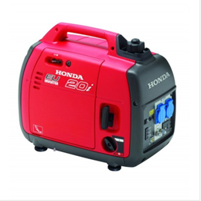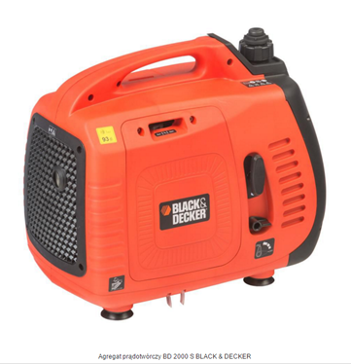
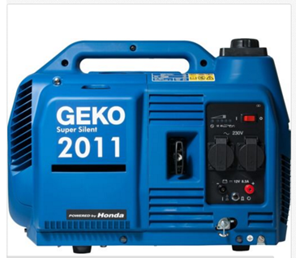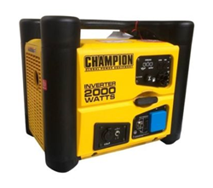
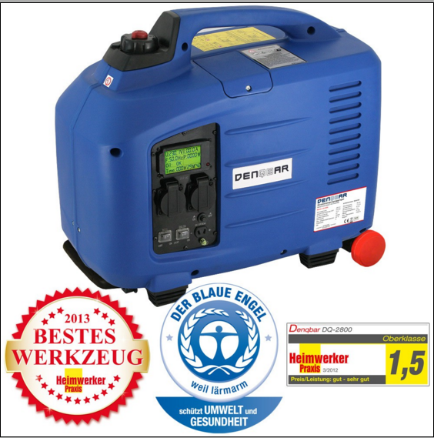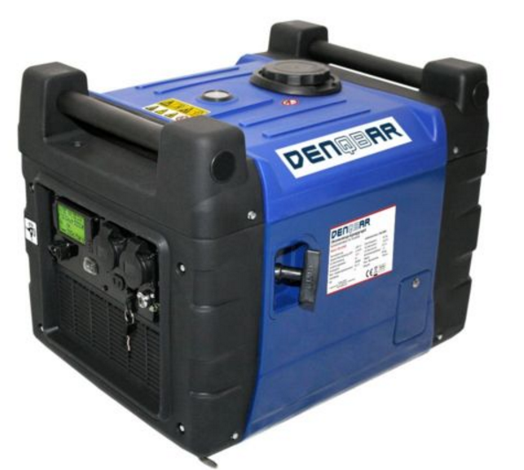
WASHING MACHINES
  - Overview
There seem few (if any) truly expedition vehicle/camper designed washing machines available, and instead a compromise needs to be adopted by the expedition vehicle owner – one can choose from the following types:
- Smaller versions of standard household washers, i.e. a maximum of 6kg washing loads
- Slim-line versions of household washer-dryers, i.e. with 3 to 3.5 kg loads, and physical ‘depth’ of 45 to 50cm
- Portable OR mini washing machines (with/without spinner-dryers)
- Hand or foot operated washing machines (non-electrical)
Given that the expedition traveler by definition spends many months away on the road, and in general does not want to be tied to weekly visits to laundry shops located in ‘civilisation’, then a washing machine, or an alternative means to wash clothes beyond ‘hand washing’ should be seen as necessary item rather than a luxary. Dependent on the type used, then there is clearly a fairly considerable impact on the ‘resources’ of the expedition vehicle, i.e. water usage, power and space, although options from the above types are suitable from the smallest to the largest of expedition vehicles.
An important point to note is that none of the appliances included have been specifically developed for the campervan/expedition vehicle market, and therefore in terms of choosing a preferred model based on proven field experience is difficult. Most front loading washing machines are typically delivered when ‘new’ in a ‘locked down’ state (unlocked prior to being used), and it is well known that over time the bearings can deteriorate through normal usage in a stationary ‘home environment’, therefore it is not clear how long term travel in expedition vehicles will accelerate bearing wear. However, given the often hard lives of washing machines from over-loading and uneven loads, we might guess that this will not be of major concern, at least over a journey time of 1 or 2 years.
The smaller load and mini washing machines included, are similarly designed towards the home owner, who has space or financial limitations, rather than any specific campervan/expedition vehicle owner, albeit such needs are addressed.

  - Recommended models
Given the clear differences between the main model types, then it is hard to recommend a single product that stands above the other models, especially since none of the models have been specifically targeted towards campervan or expedition vehicle usage.
The Dometic compact washing machine (3kg load), whilst being sold by a credible campervan manufacturer, is mainly sold in Asia, and seems to be sold more for it’s relatively small size, than for any ‘mobile or robustness’ characteristics – it’s relatively high price, and apparent lack of availability in Europe, means that we do not specifically recommend this appliance, although expect that it’s performance will be good.
Another frontloading ‘compact’ appliance that is relatively difficult to source across Europe is the Kenwood mini (3kg load), which is favoured by Unicat in their Expedition vehicles, although, apart from the relatively small size of these washing machines, they do not stand out from some of the other well known brands – physically this appliance is slightly smaller than the Dometic. Similar to both is a unit from AEG, although it’s relatively long wash cycle time of 127 minutes is the longest of the 3kg machines.
Slimline versions of household machines whilst still being 85cm tall, can offer an increased wash load of 6kg compared to the above 3kg, including models from LG, Samsung and Whirlpool, with the LG having the shortest wash cycle of any of the frontloading appliances.
All of the frontloaders are 240v powered, heat the water, include spin cycles, operate fully automatic. The power requirements of up to 2.2 kW mean that a 3kW Inverter will need to be fitted to supply the required 240v and/or a 3kW generator. Energy usage can be reduced by feeding hot water from the expedition hot water system into any of the above washing machines.
The third category of washing machines are basically single or twin tub top loaders, in which the user chooses whether to use cold, warm or hot water, and a spin cycle is also possible, whether in the single wash tub, or in the separate 2nd spin tub. All units operate from 240v although the wash times are significantly less than the frontloaders (up to 15 minutes, apart from the Sphere at 38 minutes), and wash loads vary from 2 to 3 kg. The user is responsible to empty the ‘washing water’, and adding the rinsing water. The power requirements vary from only 100 to 250W, and hence a standard 1kW Inverter will happily power these units, and given the short wash times, there will be little impact on any battery stored energy.
The simplest, cheapest and greenest washing machines are manual ly powered devices, that wash in whatever water temperature the operator chooses, but require operating for only 2 to 5 minutes – as with the top loaders, the operator must release the washing water and replace with fresh rinsing water. Typically, 20 litres is enough to wash/rinse a single load of clothes (the ‘frontloaders use 2 to 3 times that quantity).
The Wonderwash (US name, ‘White Magic’ in Europe) has many good reviews, and clearly washes clothes efficiently and well, although the lack of a spinner function, means that the traveler will either need to wring out the wet clothes by hand and/or keep a separate low powered spin-dryer (of which Wonderwash also provide a small model suitable for 1.5 kg of clothes).
The Virego ‘Drumi’ takes one stop further than the ‘Wonderwash’, and whilst requiring the user to fill with water for rinsing, does also include a form of ‘spin drying’, saving the need to do this ‘by hand’ or by having a separate spin-dryer.
It is hard to recommend any type of washing appliance above another, although the Virego Drumi is so quick to wash, uses so little washing detergent and water, and leaves clothes with only a little ‘natural air’ drying, that despite the manual effort required, for many travelers the washing experience will fit into their expedition ‘lifestyle’. It is noted however, that the product was developed by an innovation company, and as such, the product is not available until later this year.
At the other end of the spectrum, the built-in, fully automatic frontloaders, will provide a washing experience similar to ‘at home’, and providing that one is ‘aware of’ the power/water usage should not limit the traveler too strongly. For us, the top loaders whilst being powered, are not as ‘automatic or convenient’ as the frontloaders, and therefore we tend to not favour them, but for an expedition vehicle where space is tight, then the small top loaders offer very small profiles compared to the front loaders.

Model | Type | Load  (Kg) | Energy (kwh) or Power (W) | Min water  (Litres) | Min/Max cycle time  (mins) | Heats water | Size (HxWxD)  cm | Voltage | Price  (EUR) | Link/review – with dryer ??
Samsung WF 7802 XEC/XEG | Front | 8 | 2400 | 41 | 82/198 | YES | 85x60x45 | 240V | 600 | http://www.testberichte.de/p/samsung-tests/wfs-7802-testbericht.html
Whirlpool AWS 6126 | Front | 6 | 2100 | - | 30 | YES | 85x60x45 | 240V | 334 | http://www.whirlpool.de/produkte/waschen-trocknen/waschmaschinen/waschmaschine-6-kg-aws-6126
LG SLIM360 | Front | 3,5 | - | - | 17 | YES | 85x60x36 | 240V | - | Hard to get in Europe  https://www.youtube.com/watch?v=405HApTEffg  http://www.lg.com/hk_en/washing-machines/lg-WF-SLIM360/technical-specifications
Dometic WMD 1050 | Front/ compact | 3 | 1900 | 45 | 90 | YES | 67x50x52 | 240V | 1295 AUS$ | Hard to get in Europe  https://www.dometicrvcentre.com.au/onlinestore1/kitchen/compact-washing-machine
Kenwood mini 850 | Front/ compact | 3 | 2200 | ? | 60 | YES | 68x46x46 | 240V | 699 | Unicat use  http://www.kenwoodworld.com/de-ch/produktuebersicht/haushalt-produkte/waschvollautomaten/waschvollautomat-mini-850
AEG LC53500 | Front/ compact | 3 | - | - | 127 | YES | 67x50x55 | 240V | 444 | http://www.testberichte.de/p/aeg-tests/lavamat-lc53500-testbericht.html
Euronova 1000F | Front/ compact | 3 | 2200 | 44 | 100 | YES | 68x46x46 | 240V | 529 | http://www.testberichte.de/p/euronova-tests/1000-f-testbericht.html
Sphere | Top | 3 | 235 | 20 | 38 | NO | 74x41x42 | 240V | 329 AUS$ | Australian market  http://www.rvpartsexpress.com.au/kitchen-cabin/laundry-needs/sphere-3kg-automatic-mini-washing-machine-240v.html
Sphere | Top | 2,5 | ? | ? | ? | NO | 64x41x42 | 240V | 299 AUS$ | Australian market  (as above)
Portawash/ Portawash plus | Top/twin | 3/3.5 | 230/250 | 22 | 15 | NO | 61x42x58 | 240V | 130/ 150 | http://www.towsure.com/leisurewize-portawash-twin-tub-washing-machine
The Laundry Pod | Top | 3 | n/a | 24 | 10 | NO | 31x31x31 | Manual | 80 USD | https://www.youtube.com/watch?v=imyhYWRp1cE  http://www.storebound.com/laundrypod/shop/laundry-pod#video
Brunner Flipper | Mini-top | 2 | 150 | 24 | 15 | NO | 49x33x38 | 240v | 93 | http://www.campingshop-24.de/campingartikel/waschmaschinen/26053/brunner-waschmaschine-flipper  http://www.brunner.it/en/electrical-products-ac-dc/716-flipper-716.html
Wonderwash / Brunner white magic | n/a | 2.2 | n/a | 18 | 10 | NO | 25x25x30 | Manual | 70 | https://www.youtube.com/watch?v=R1hD-KYfmIY&ebc=ANyPxKqww09z5o2tQvacX78DFbCIiLglBIp2Qfv6Vz4qzOX4scxDqm8HCTS7zVBoFQwzIEvRfrEV47iIlhlSB1ZrMsfKvQZ5_g  http://www.campingshop-24.de/campingartikel/waschmaschinen/20227/camping-waschmaschine-white-magic  http://www.laundry-alternative.ca/product/The-Wonderwash
North Gear | n/a | 2.3 | n/a | ? | 10 | NO |  | Manual
Drumi | n/a | 5 pounds | n/a | 24 | 10 |  | 50x38x38 | Manual | 229 USD | http://www.yirego.com/  https://www.youtube.com/watch?v=NVOs-fU-mfQ  NOTE – not available until October 2016

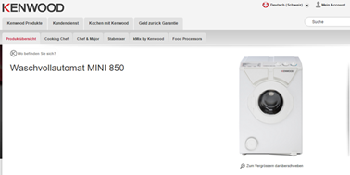
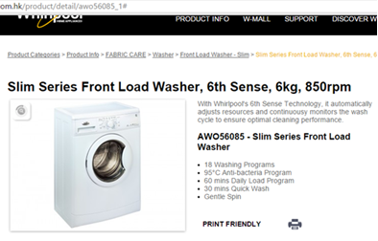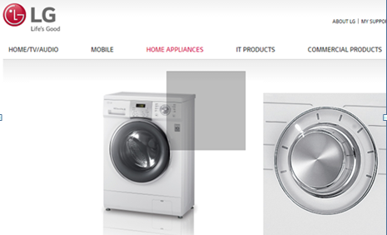
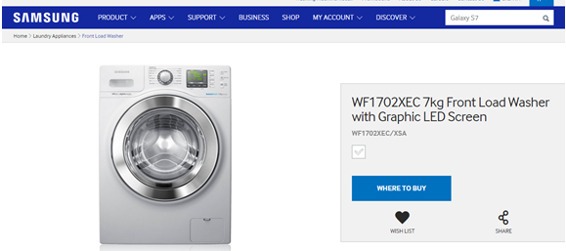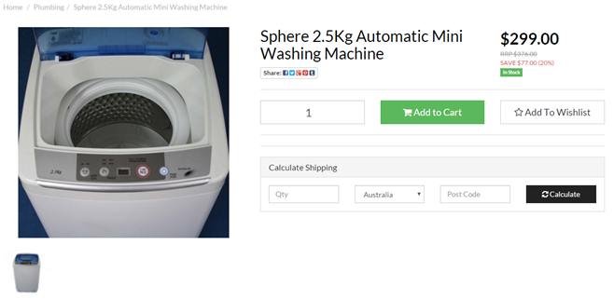
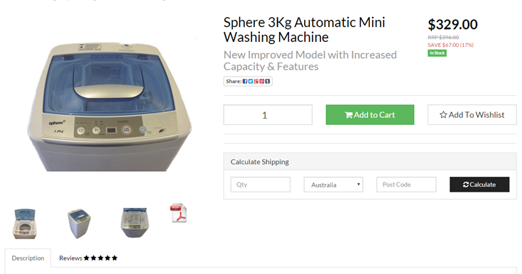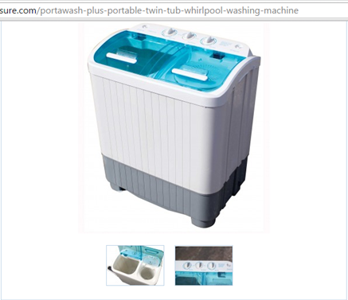

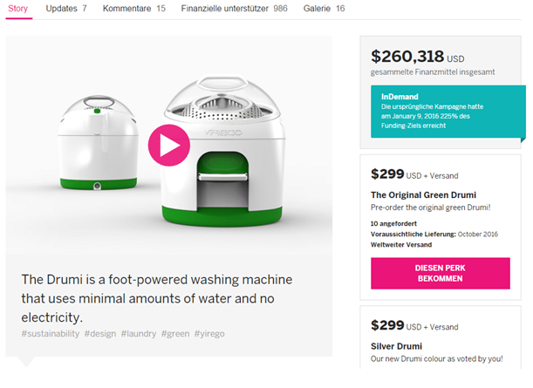
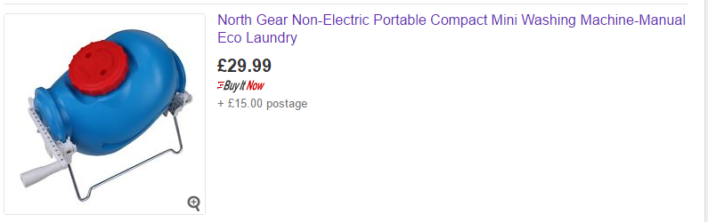

VACUUM CLEANERS
  - Overview
Whilst no expedition vehicle is particularly large, the inclusion of a ‘small’ vacuum cleaner offers a useful aid in keeping the vehicle clean, given that there is sometimes a tendency to not ‘take off shoes’, particularly when entering/leaving the vehicle through the tunnel access from the drivers cabin. Additionally, given some of the restricted access points, then the presence of a strong suction in addition or instead of a brush, really aids in keeping the vehicle clean.
12v and/or hands-free (cable-less or battery) vacuum cleaners have been available for many years in the marketplace, mainly for the automotive market. Additionally, there are also low powered 240v models available, that place little load on your vehicles batteries. Today, there are many well performing models, and they should not be compared to perhaps the battery powered versions of 20 years ago, in terms of usability or effectiveness
  - Recommended models
In many years in our own home, garage & workshop, having owned/tested various model types and manufacturers of vacuum cleaner, then we are strong advocats of the Dyson range of vacuum cleaners, and are pleased that there is now available a very powerful and capable battery powered model, offering superior performance for any size of expedition vehicle, with the only disadvantage being the relatively high price. In fact these battery models are also usable around the home, offering a quick and convenient alternative to the mains cable connected models, and therefore the high purchase cost can be offset by usage when ‘not on expedition’. Charging of the battery is by 240v charger, with a running time of 20 minutes.
The Dyson name is very famous in the UK (‘get rid of the bag !’), as being the first mainstream household bagless vacuum cleaner and the success also of other products made by this innovations/inventor led company - importantly for us, we have operated ‘hard’ one Dyson cable vacuum cleaner for 20 years (whilst also operating it’s ‘replacement’ for the last 7 years) – in parallel, we have operated other ‘brand vacuum cleaners’ which despite the irritation caused by needing to include ‘bags’ in some of these, have broken or stopped working well in less than 5 years.
Regarding 12v cable vacuum cleaners then both Black and Decker models below offer very good performance, with cleanable filters, with the PAD1200 perhaps being a little better at getting into small spaces. Although the suction power available is less than with the battery powered Dyson, providing a 12v socket is available, and that the customer does not wish to re-use a Dyson in the home and in the expedition vehicle, then we would recommend either of the two Black and Decker cleaners being the best combination of value and performance – having said this, the other models shown will perform the required task.
Model | Power (W) | Running time | Bin Volume (l) | Cost (EUR) | Comment/link
Dyson v6 trigger | 350 | 20 mins | 0,4 | 230 | Stronger than most leading mains operated vacuum cleaners, various models, best with motorized head (in the ‘motorhead’)  https://www.youtube.com/watch?v=gQvg7PkFBhg  https://www.youtube.com/watch?v=M9bI4pm-7aM  https://www.youtube.com/watch?v=P313JNN7hrI
Bosch PAS 18 |  | 16 mins |  | 178 | https://www.bosch-garden.com/de/de/bosch-gartengeraete/gartengeraete/pas-18-li-3165140761802-199944.jsp  https://www.youtube.com/watch?v=_8UaBOp2cZo  https://www.youtube.com/watch?v=xneKd0vwKRA
Black & Decker ADV1220 | (12v) | 12v cable | 0,6 | 45 | Our favourite if ‘cable-less’ is not required  http://www.blackanddecker.co.uk/homeproducts/productdetails/catno/ADV1220/  https://www.youtube.com/watch?v=1wyuQC40e4s&ebc=ANyPxKq6DJJgqhN98WZ3ZRqUjKE5ij4ajPgQsithOfkFpDzuEs977jpud1ZEgWm0LOz-VYBU3kvIoPNnFVhtJg9hyiTvIb9WQw
Black & Decker PAD1200 | (12v) | 12v cable | 0,5 | 60 | http://www.blackanddecker.co.uk/homeproducts/productdetails/catno/PAD1200/  https://www.youtube.com/watch?v=ME9QiPcPclk
Dirt Devil M137 Gator | (18v) | ? mins | 0,2 | 65 (129)* | https://www.youtube.com/watch?v=xJwbVj7_Viw  http://www.dirtdevil.de/handstaubsauger/gator-18v-m137
Mestic Compact | 500 | 230v cable | - | 40 | http://www.fritz-berger.de/product/Mestic-Staubsauger-compact/MesticStaubsaugercompact448560?category=wasserkocher-staubsauger
Tristar Dustbuster | 45 | 15 mins | 0,5 | 35 | Wet and dry operation, China made  http://www.tristar.eu/en/Home_Appliances/KR-2156/3/3583  http://www.fritz-berger.de/product/Nass--Trocken-Handstaubsauger/NassTrockenHandstaubsauger447980?category=wasserkocher-staubsauger

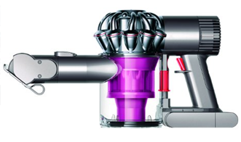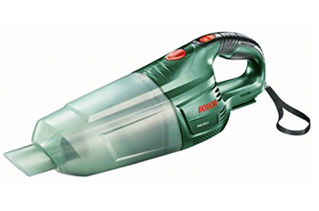
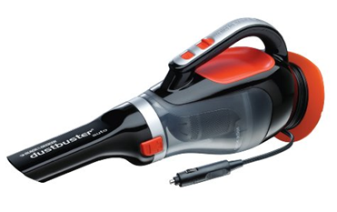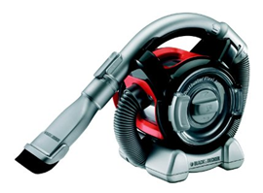
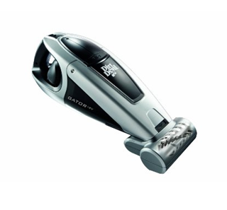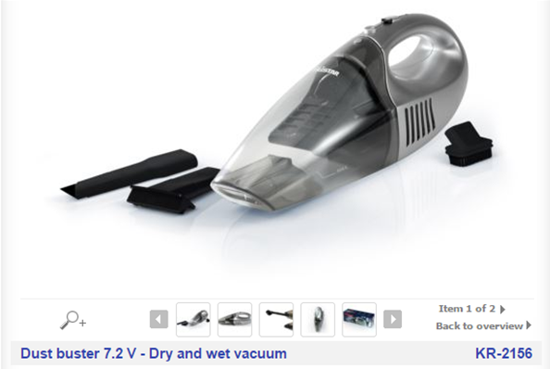
END OF DOCUMENT

